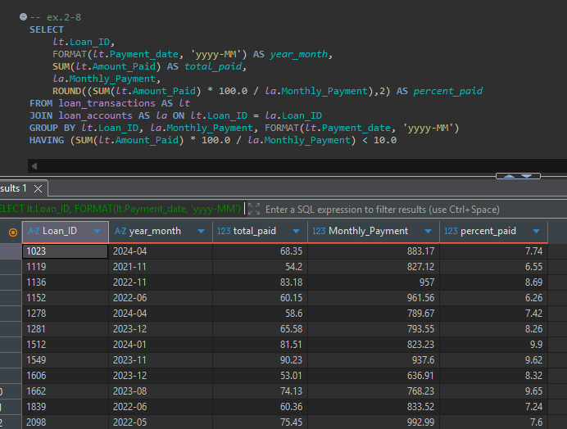
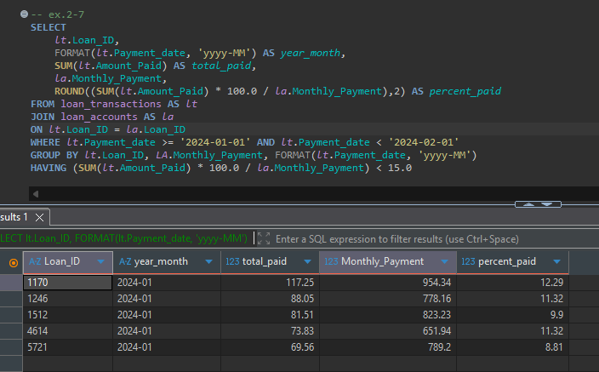
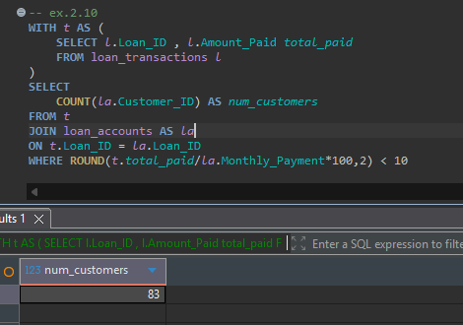
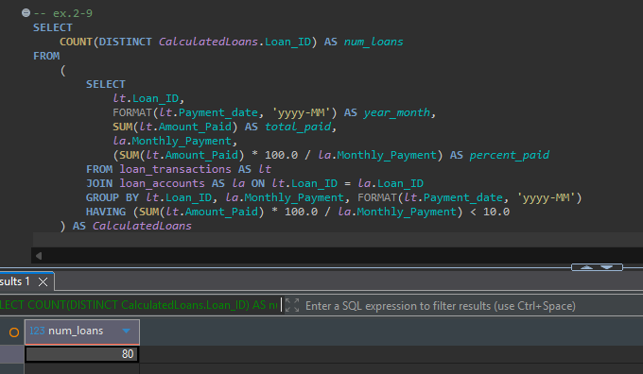

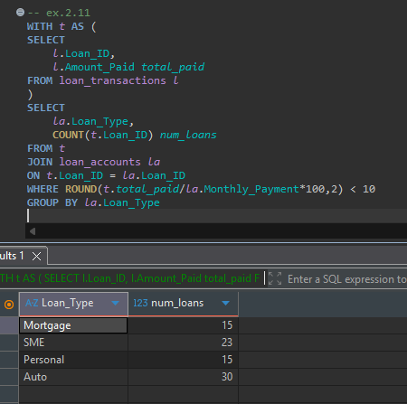
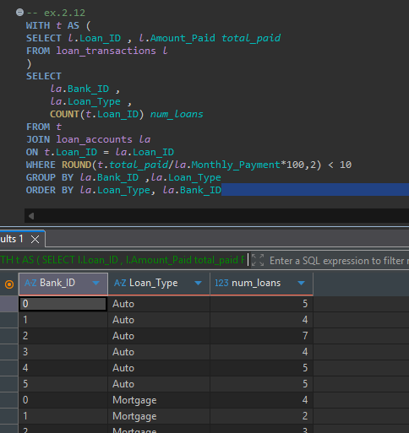
-- Wrokshop2 --

-- ex.2-1

/**SELECT

l.Loan_ID,

MAX(DATEDIFF(day,l.Due_Date,l.Payment_Date)) as max_dpd

FROM loan_transactions AS l

GROUP BY l.loan_ID

ORDER BY l.Loan_ID

WITH t AS (

SELECT

l.Loan_ID,

MAX(DATEDIFF(day,l.Due_Date,l.Payment_Date)) as max_dpd

FROM loan_transactions AS l

GROUP BY l.loan_ID

)

SELECT * FROM t

WHERE max_dpd > 90

WITH t AS (

SELECT

l.Loan_ID,

MAX(DATEDIFF(day,l.Due_Date,l.Payment_Date)) as max_dpd

FROM loan_transactions AS l

GROUP BY l.loan_ID

)

SELECT

t.*,l.Loan_Type -- t.* = all column of t

FROM t

INNER JOIN loan_accounts l

ON t.loan_id = l.loan_id

WHERE max_dpd > 90**/

WITH t AS (

SELECT

l.Loan_ID,

MAX(DATEDIFF(day,l.Due_Date,l.Payment_Date)) as max_dpd

FROM loan_transactions AS l

GROUP BY l.loan_ID

)

SELECT

l.Loan_Type, -- t.* = all column of t

COUNT(l.Loan_ID) AS num_loans

FROM t

INNER JOIN loan_accounts l

ON t.loan_id = l.loan_id

WHERE max_dpd > 90

GROUP BY l.loan_type

ORDER BY l.Loan_Type

-- ex.2-2

WITH t AS (

SELECT

l.Loan_ID,

MAX(DATEDIFF(day,l.Due_Date,l.Payment_Date)) as max_dpd

FROM loan_transactions AS l

GROUP BY l.loan_ID

)

SELECT

l.Loan_Type, -- t.* = all column of t

ROUND(SUM(l.loan_amount),2) AS total_loan_amout

FROM t

INNER JOIN loan_accounts l

ON t.loan_id = l.loan_id

WHERE max_dpd > 90

GROUP BY l.loan_type

ORDER BY SUM(l.loan_amount) DESC

-- ex.2-3

WITH t AS (

SELECT

l.Loan_ID,

MAX(DATEDIFF(day,l.Due_Date,l.Payment_Date)) as max_dpd

FROM loan_transactions AS l

GROUP BY l.loan_ID

)

SELECT

l.Loan_Type, -- t.* = all column of t

l.Bank_ID,

ROUND(SUM(l.loan_amount),2) AS total_loan_amout

FROM t

INNER JOIN loan_accounts l

ON t.loan_id = l.loan_id

WHERE max_dpd > 90

GROUP BY l.loan_type,l.Bank_ID

ORDER BY l.Loan_Type ASC,l.Bank_ID ASC

-- ex.2-4

WITH t AS (

SELECT

l.Loan_ID,

MAX(DATEDIFF(day,l.Due_Date,l.Payment_Date)) as max_dpd

FROM loan_transactions AS l

GROUP BY l.loan_ID

)

SELECT

*,

CASE

WHEN max_dpd <= 0 THEN 'DPD <= 0'

WHEN max_dpd BETWEEN 1 AND 30 THEN 'DPD = 1-30'

WHEN max_dpd BETWEEN 31 AND 60 THEN 'DPD = 31-60'

WHEN max_dpd BETWEEN 61 AND 90 THEN 'DPD = 61-90'

ELSE 'DPD > 90'

END AS dpd_group

FROM t

-- ex.2-5

WITH t AS (

SELECT

l.Loan_ID,

MAX(DATEDIFF(day,l.Due_Date,l.Payment_Date)) as max_dpd

FROM loan_transactions AS l

GROUP BY l.loan_ID

)

SELECT

CASE

WHEN max_dpd <= 0 THEN 'DPD <= 0'

WHEN max_dpd BETWEEN 1 AND 30 THEN 'DPD = 1-30'

WHEN max_dpd BETWEEN 31 AND 60 THEN 'DPD = 31-60'

WHEN max_dpd BETWEEN 61 AND 90 THEN 'DPD = 61-90'

ELSE 'DPD > 90'

END AS dpd_group,

COUNT(t.loan_ID) AS num_loans

FROM t

GROUP BY

CASE

WHEN max_dpd <= 0 THEN 'DPD <= 0'

WHEN max_dpd BETWEEN 1 AND 30 THEN 'DPD = 1-30'

WHEN max_dpd BETWEEN 31 AND 60 THEN 'DPD = 31-60'

WHEN max_dpd BETWEEN 61 AND 90 THEN 'DPD = 61-90'

ELSE 'DPD > 90'

END

-- ex.2-6

WITH t AS (

SELECT

l.Loan_ID,

MAX(DATEDIFF(day,l.Due_Date,l.Payment_Date)) as max_dpd

FROM loan_transactions AS l

GROUP BY l.loan_ID

)

SELECT

l.loan_type,

CASE

WHEN max_dpd <= 0 THEN 'DPD <= 0'

WHEN max_dpd BETWEEN 1 AND 30 THEN 'DPD = 1-30'

WHEN max_dpd BETWEEN 31 AND 60 THEN 'DPD = 31-60'

WHEN max_dpd BETWEEN 61 AND 90 THEN 'DPD = 61-90'

ELSE 'DPD > 90'

END AS dpd_group,

COUNT(t.loan_ID) AS num_loans

FROM t

INNER JOIN loan_accounts l

ON t.loan_id = l.loan_id

GROUP BY

l.loan_type,

CASE

WHEN max_dpd <= 0 THEN 'DPD <= 0'

WHEN max_dpd BETWEEN 1 AND 30 THEN 'DPD = 1-30'

WHEN max_dpd BETWEEN 31 AND 60 THEN 'DPD = 31-60'

WHEN max_dpd BETWEEN 61 AND 90 THEN 'DPD = 61-90'

ELSE 'DPD > 90'

END

ORDER BY l.loan_type, dpd_group

-- ex.2-7
SELECT
lt.Loan_ID,
FORMAT(lt.Payment_date, 'yyyy-MM') AS year_month,
SUM(lt.Amount_Paid) AS total_paid,
la.Monthly_Payment,
ROUND((SUM(lt.Amount_Paid) * 100.0 / la.Monthly_Payment),2) AS percent_paid
FROM loan_transactions AS lt
JOIN loan_accounts AS la
ON lt.Loan_ID = la.Loan_ID
WHERE lt.Payment_date >= '2024-01-01' AND lt.Payment_date < '2024-02-01'
GROUP BY lt.Loan_ID, LA.Monthly_Payment, FORMAT(lt.Payment_date, 'yyyy-MM')
HAVING (SUM(lt.Amount_Paid) * 100.0 / la.Monthly_Payment) < 15.0

-- ex.2-8
SELECT
lt.Loan_ID,
FORMAT(lt.Payment_date, 'yyyy-MM') AS year_month,
SUM(lt.Amount_Paid) AS total_paid,
la.Monthly_Payment,
ROUND((SUM(lt.Amount_Paid) * 100.0 / la.Monthly_Payment),2) AS percent_paid
FROM loan_transactions AS lt
JOIN loan_accounts AS la ON lt.Loan_ID = la.Loan_ID
GROUP BY lt.Loan_ID, la.Monthly_Payment, FORMAT(lt.Payment_date, 'yyyy-MM')
HAVING (SUM(lt.Amount_Paid) * 100.0 / la.Monthly_Payment) < 10.0

-- ex.2-9
SELECT
COUNT(DISTINCT CalculatedLoans.Loan_ID) AS num_loans
FROM
(
SELECT
lt.Loan_ID,
FORMAT(lt.Payment_date, 'yyyy-MM') AS year_month,
SUM(lt.Amount_Paid) AS total_paid,
la.Monthly_Payment,
(SUM(lt.Amount_Paid) * 100.0 / la.Monthly_Payment) AS percent_paid
FROM loan_transactions AS lt
JOIN loan_accounts AS la ON lt.Loan_ID = la.Loan_ID
GROUP BY lt.Loan_ID, la.Monthly_Payment, FORMAT(lt.Payment_date, 'yyyy-MM')
HAVING (SUM(lt.Amount_Paid) * 100.0 / la.Monthly_Payment) < 10.0
) AS CalculatedLoans

-- ex.2.10
WITH t AS (
SELECT l.Loan_ID , l.Amount_Paid total_paid
FROM loan_transactions l
)
SELECT
COUNT(la.Customer_ID) AS num_customers
FROM t
JOIN loan_accounts AS la
ON t.Loan_ID = la.Loan_ID
WHERE ROUND(t.total_paid/la.Monthly_Payment*100,2) < 10

-- ex.2.11
WITH t AS (
SELECT
l.Loan_ID,
l.Amount_Paid total_paid
FROM loan_transactions l
)
SELECT
la.Loan_Type,
COUNT(t.Loan_ID) num_loans
FROM t
JOIN loan_accounts la
ON t.Loan_ID = la.Loan_ID
WHERE ROUND(t.total_paid/la.Monthly_Payment*100,2) < 10
GROUP BY la.Loan_Type

-- ex.2.12
WITH t AS (
SELECT l.Loan_ID , l.Amount_Paid total_paid
FROM loan_transactions l
)
SELECT
la.Bank_ID ,
la.Loan_Type ,
COUNT(t.Loan_ID) num_loans
FROM t
JOIN loan_accounts la
ON t.Loan_ID = la.Loan_ID
WHERE ROUND(t.total_paid/la.Monthly_Payment*100,2) < 10
GROUP BY la.Bank_ID ,la.Loan_Type
ORDER BY la.Loan_Type, la.Bank_ID

